**Ex.no:8**

**Date:10.9.2024**

**NMAP TO DISCOVER LIVE HOSTS**

**AIM:**

To study Nmap tool using TryHackMe platform**.**

**TASK 1 – INTRODUCTION:**

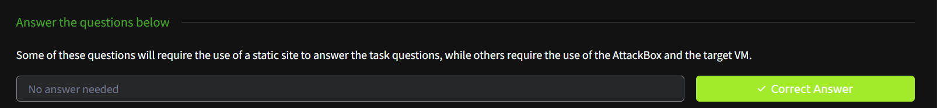

**TASK 2 – SUBNETWORKS:**

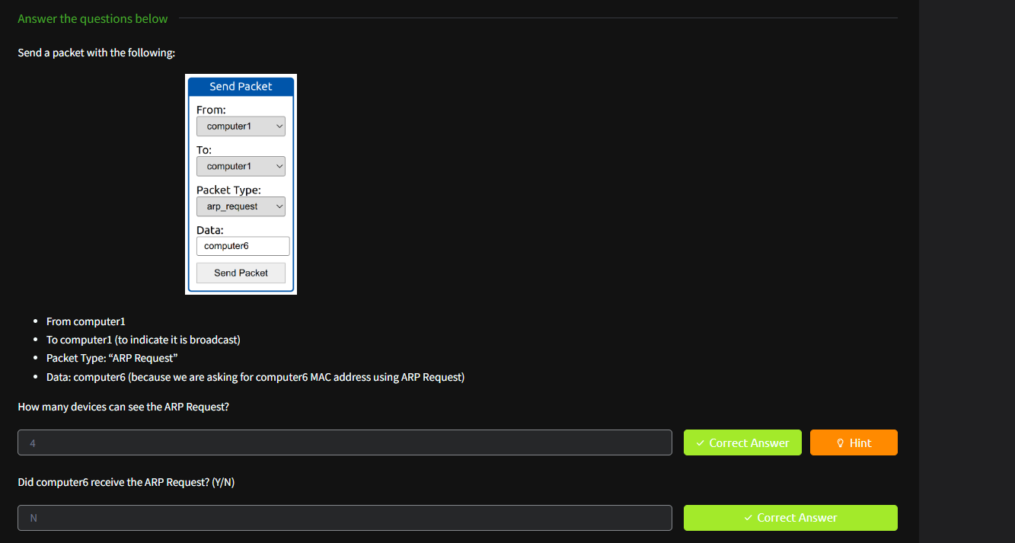

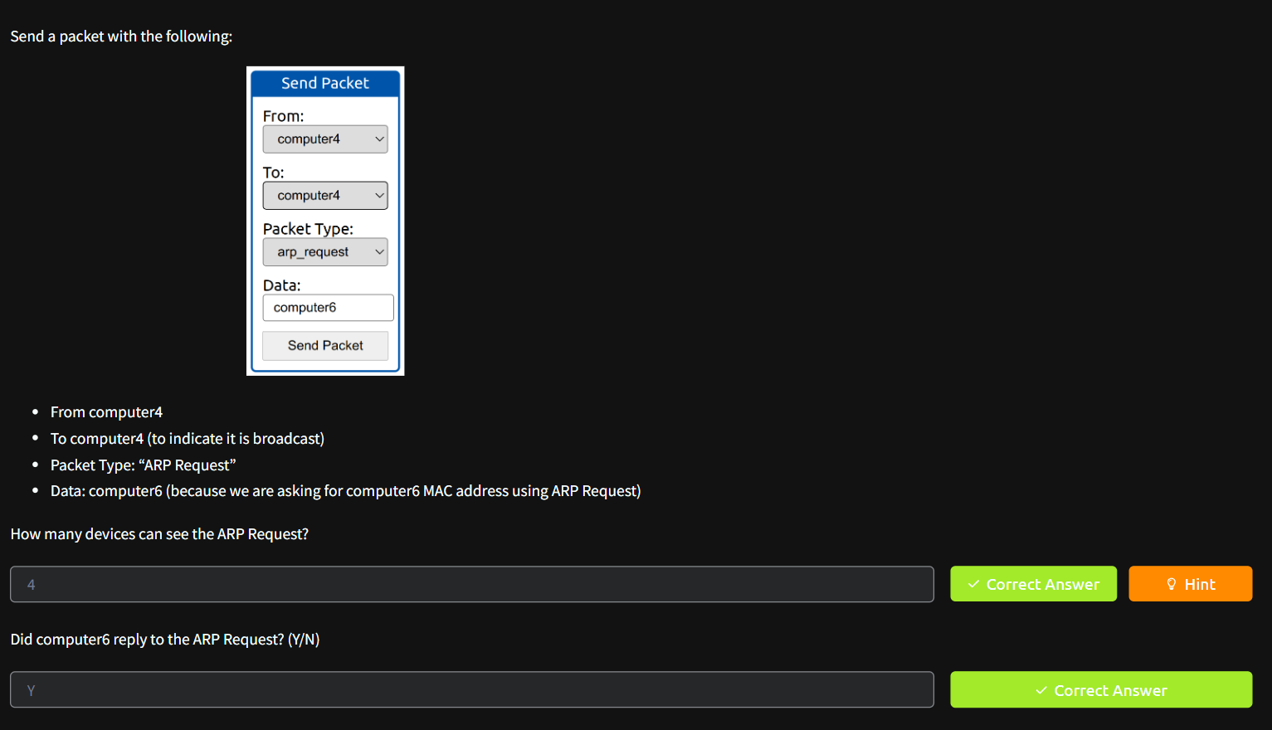

**TASK 3 - ENUMERATING TARGETS:**

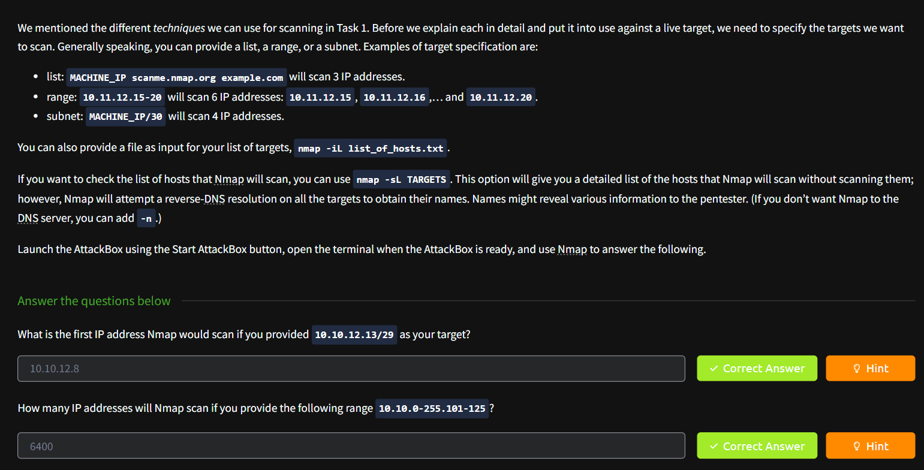

**TASK4 - DISCOVERING LIVE HOSTS:**

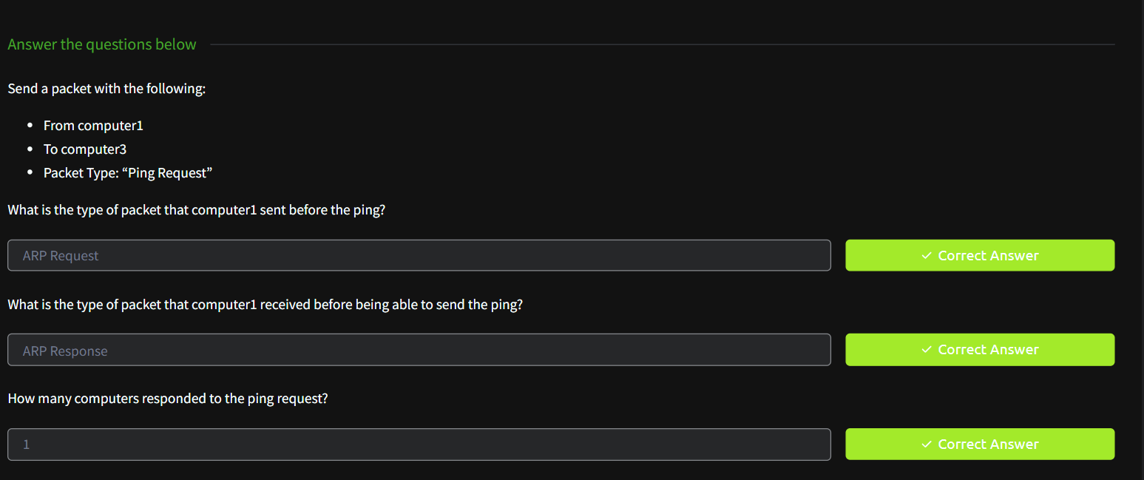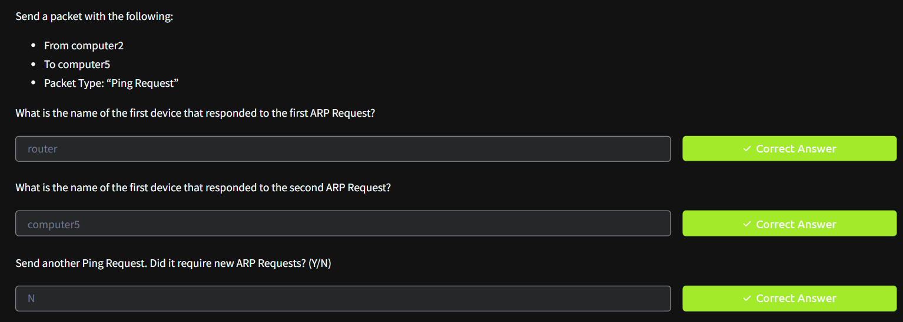

**TASK 5 - NMAP HOST DISCOVERY USING ARP:**

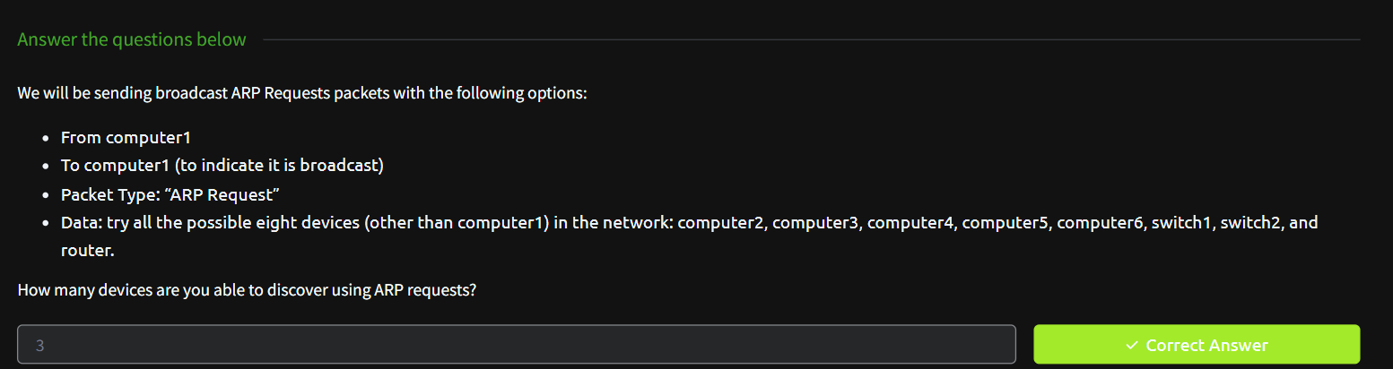

**TASK 6 - NMAP HOST DISCOVERY USING ICMP:**

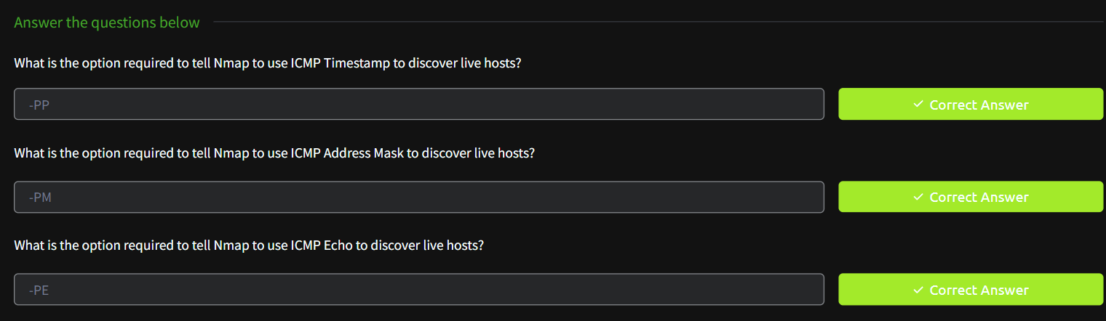

**TASK 7 - NMAP HOST DISCOVERY USING TCP AND UDP:**

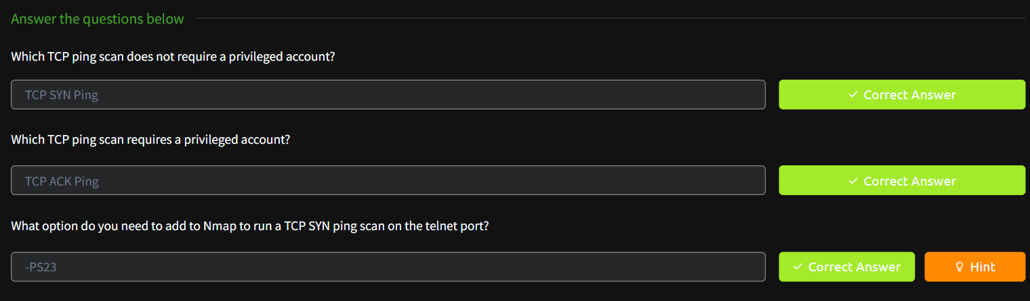

**TASK 8 - USING REVERSE-DNS LOOKUP:**

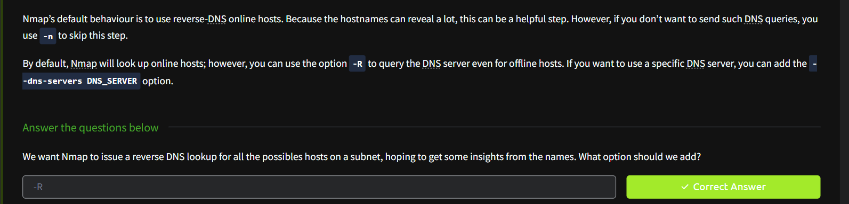

**TASK 9 – SUMMARY:**

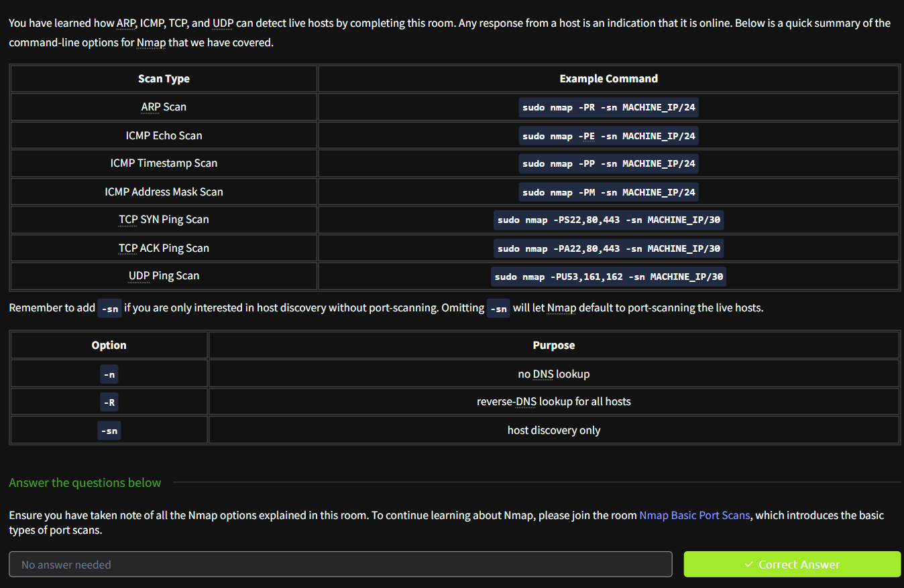

**RESULT:**

**Hence, Nmap to discover live hosts is studied.**